


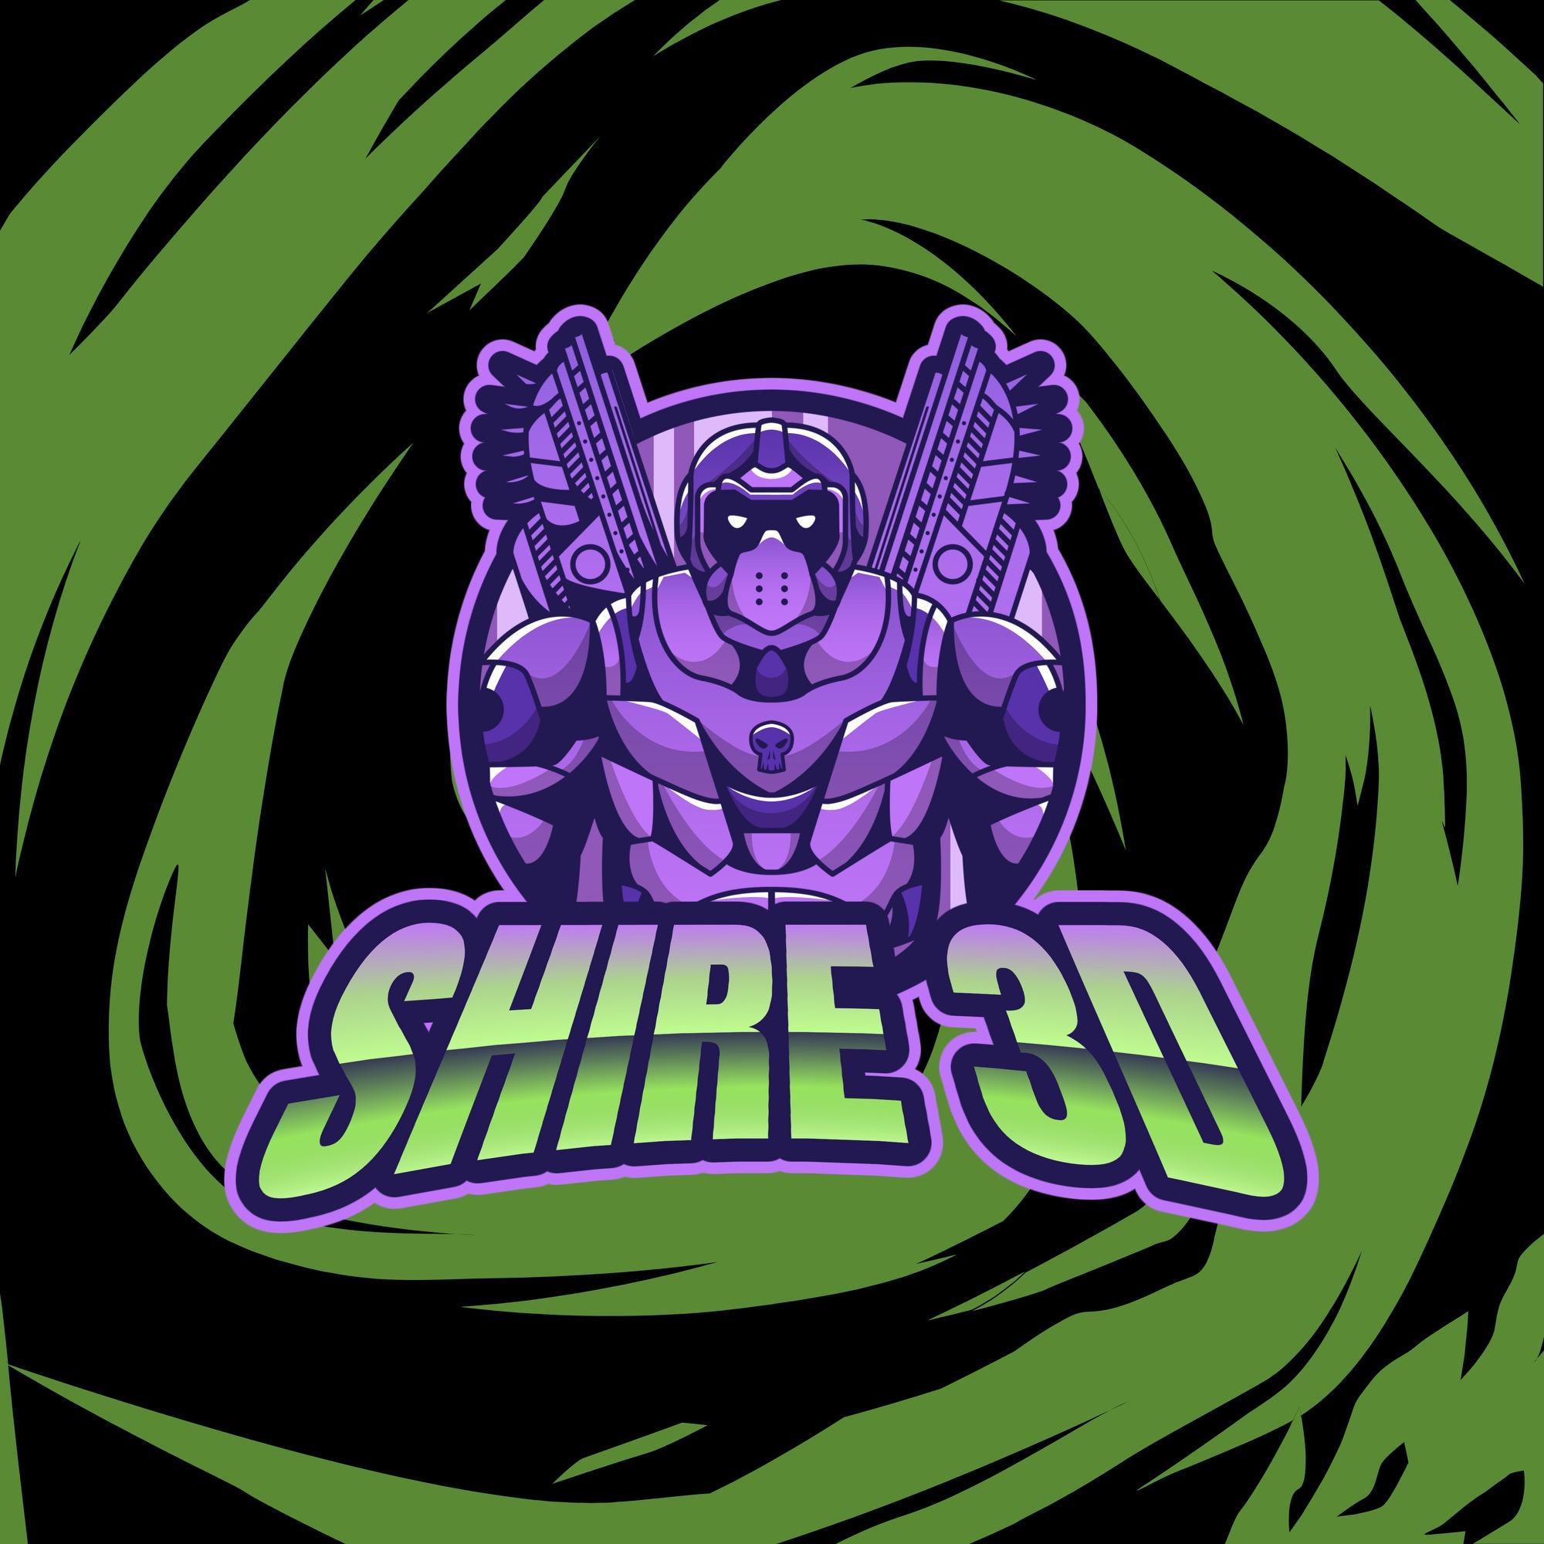

Shire 3D

Business plan
Date: 08/07/2024
[Use the italicised guidance throughout this template for help completing your business plan.
You may wish to remove this text before you finalise your plan. Use the grey fields to type your answers.]

1. Key details

1.1 Registration details
Business name  Registered or proposed name. | Shire 3D  Awaiting Approval
Date registered | 01/08/2024
State registered in | Western Australia
Business structure | Sole Trader
Australian business number (ABN) Must be completed! | 49597815496
Australian company number (ACN)
If a company.
Director Number
If a company.
Licences and permits
Australian, state and local.

1.2 Contact details
Name | Raymond Morrison
Phone | 459570046
Mobile | 459570046
Email | shire3dprints@gmail.com
Address | 40 Toledo CCT Port Kennedy WA 6172

1.3 Online and social media detail
 | Address/details
Website | Shire3d.etsy.com
Facebook | Facebook.com/Shires3D
TikTok | @Shire3D

Contents
1. Key details 2
1.1 Registration details 2
1.2 Contact details 2
1.3 Online and social media detail 2
2. The Business 5
2.1 Plan summary 5
2.2 Our why 5
2.3 Our vision 6
2.4 Our mission (Benefit Statement) 6
2.5 Operations 6
2.5.1 Products and services (Revenue Streams) 6
2.5.2 Production (Key Actions) 6
2.5.3 Sales and distribution channels (Channels) 7
2.5.4 Digital technology 7
2.5.5 Information management 8
2.5.6 Customer Relations (Customer Relations) 8
2.6 Assets and Key Resources (Key Resources) 8
2.7 Intellectual property 9
2.8 Key people & partners (Key Partners) 10
2.8.1 Our staff 10
2.8.2 Sources of advice and support 10
2.8.3 Skill and staff retention strategies 10
3. The market 11
3.1 The problem 11
3.2 Our solution, features and benefits (Value Proposition) 11
3.3 Our target market (Customer Segment) 12
Customer Persona 12
Demographics 12
Psychographics 13
Geographic 13
Behavioural 14
3.4 Advertising and promotion (Channels) 14
3.5 The competition 15
3.6 Pricing strategy 15
3.7 SWOT analysis 16
3.7.1 How we’ll address each weakness and threat. 16
3.8 PEST analysis 17
3.8.1 How we’ll address each of the PEST issues 17
4. Risk management 18
4.1 Risk assessment 18
4.2 Insurance 19
4.3 Insurance Compliance 19
4.4 Laws we’ll need to comply with 20
4.5 Taxation we will need to register for 20
5. Goals and Key Actions (Key Actions) 21
5.1 Goals the first year 21
5.2 Goals for the next 3 years 21
6. Work priorities 22
6.1 Personal Commitments 22
6.2 Work week planner 22
7. The finances 23
7.1 Finance needed 23
7.2 Sources of funding 23
7.3 Balance forecast 23
7.4 Profit and loss forecast 23
7.5 Cash flow forecast 23
7.6 Break-Even Analysis (Cost Structure) 24
8. Supporting document checklist 25
8.1 Previous NEIS or Self-Employment Assistance? 25
8.2 Previous NEIS or Self-Employment Assistance Business Idea 26
8.3 What is different in the current plan or your circumstances? 26

2. The Business

2.1 Plan summary
2.1.1 What our business does  The products or services we sell. | We will print a varied amount of different objects ranging from Mobile phone holder to Movie Props and include Disability Aids for all kinds of disabilities.
2.1.2 Our target market  Who would specifically buy your product or service? | Our target market is anyone at any age. Our specialist markets will be Disabled personnel
2.1.3 Our unique selling point / Features and benefits  What makes you different as a business? | We will sell to nearly anyone and even offer custom print jobs. But in later years we would love to be able to print objects to help people have a better life.  Our business is different as it comes from a disabled person who has difficulty in certain areas. So knows some peoples difficulties
2.1.4 Our business goals  What do you want to achieve long term? | In the long run we would love to be able to print some objects and give away some prints to Charities at no cost loss.  A long term goal would be to start our own charity and help even more than we can
2.1.5 Our history  Industry experience, major achievements. | Our history has been a hobby for a long time and finally getting the confidence to sell our prints

2.2 Our why
The inspiration behind the business.
The Inspiration for Shire 3D is to help prove to others, Even with a life long disability we are still able to provide and help others.

2.3 Our vision
Our hopes, dreams and where we aim to go.
Our hopes are to eventually be able to print enough to be able to offer some others with no funds the help they need at no cost.

2.4 Our mission (Benefit Statement)
Who we are and why we exist?
We are a 1 person Business with goals to eventually help others. We exist to make others fantasies become a reality whether it becomes a small Dragon toy or something that can help them live a more comfortable lifestyle.

2.5 Operations

2.5.1 Products and services (Revenue Streams)
Product/service | Description | Unit price (incl. GST)
Design | We take a concept and turn into a functional design to print | $45ph
Print on Demand | Client will send us a file they want and print on demand | $34ph
Varied of ready to sell | Multiple different use prints | $14.5 - 185

2.5.2 Production (Key Actions)

Once order is in we ensure we have the correct coloured filament (if not order some), Make sure the file is sliced correctly and send to the correct printer for the size requirements. Once job is completed check over the print quality and prepare for shipping.

2.5.3 Sales and distribution channels (Channels)
Channel | Used for | Details
Etsy | Selling our licensed products or custom designs | This is our main source for now
TikTok | Marketing purposes | Easy way to show clients of their products and packaging
YouTube | Marketing and Reviewing | Show more in detailed videos of timelapses and reviews of new products
Facebook | Customer contact | This will post all info and updates for clients/customers including a face for them to contact for enquiries

2.5.4 Digital technology
Technology we plan to use for our business.
We plan to keep using Bambu Lab printers along with Creality printers. We also have Elegoo FDM printer and an Elegoo Resin printer

Technology contingency plan to use for our business.
To ensure a minimal downtime have backup Nozzles or parts that wear quickly like the belts.

2.5.5 Information management
How we collect, store and use customer and stock information.
We collect our customers information via Etsy for now but look to have an email bank like Mailchimp in the future

2.5.6 Customer Relations (Customer Relations)
How we will interact with our customers, to keep them informed and/or engaged with our business.
We plan to interact via the store front. TikTok is a way for our customers and clients to see what we use and how we design products. We have regular sales and discounts on our Etsy store front. Once the weather picks up and more reliable we can then have market stalls. I would like to eventually move away from Etsy and have my own site along with Email marketing base ready to go

2.6 Assets and Key Resources (Key Resources)

2.6.1 Premises
Current premises is our Garage in our rental property. A little cramp for now but working on making more space

2.6.2 Stock and inventory

Currently have 5 FDM 3D printers and 1 Resin Print station. We have roughly 35kgs of FDM filament varied colours. 2L of Resin Grey and 1l Black

2.6.3 Equipment (including technology)
Equipment | Date bought or leased | Cost ($)
Bambu Lab P1S Combo | 29/11/23 | 1459
Bambu Lab P1S | 09/02/24 | 1069
Elegoo Neptune 3 Max | 13/08/23 | 699.99
CR10 v3 | 15/07/22 | 538
CR30 Printmill | 15/12/22 | 950
Elegoo Saturn 3 Ultra | 26/12/23 | 939

2.7 Intellectual property

The only things I have to pay a copyright on are the printed designs BookNook (Forgecore Patreon soon be making my own), IK3D Designs and Cinderwings Designs.

2.8 Key people & partners (Key Partners)

2.8.1 Our staff
Role | Name  If role is filled. | Skills and experience
Printer/Designer | Raymond Morrison | Hobbyist for 4 years and now selling

2.8.2 Sources of advice and support
External people or organisations that provide support to our business.
Support type | Name | Skills and experience
Business Advice | APM | Helped many others setup their businesses
3D Print and Design | Makers Muse | Been a YouTuber for many years and helped me get used to Fusion 360 via his videos

2.8.3 Skill and staff retention strategies
How we maintain our own skills and if applicable the skills of our staff.
We are on the mailing list for Creality and Elegoo for all future technology changes. We also monitor MakerMuse's channel every wednesday. We have joined Patron Prints facebook group for advise in some areas but they are an American based business and not really upto date with Australia businesses

3. The market

3.1 The problem

We aim to help more people with other Disabilities which include Grip strength or hand and eye coordination

3.2 Our solution, features and benefits (Value Proposition)
How our business solves the problem – our unique selling point.
We will design our products that will help people to make their life easier if possible

3.3 Our target market (Customer Segment)

Our target audience isn't specified to just one group. As we can go for a varied amount of people in all forms of life

As long as they can afford and looking for something we have they are all welcome

The group of customers projected future.
 | Customer Persona

Demographics
Age group | 13 to 70
Profession | Any
Annual Income | 46500
Education level | Any
Family Status | Any

Psychographics
Lifestyle | Any
Goals | A Fan of my work
Pain points | Any
Spending habits | Wise but Carefree
Values | Want to bring  Character to life
Interests | Cosplay
Hobbies | Movies and TV

Geographic
City | Any
Area | Any
Region | Any
Country | Australia mostly  Aim worldwide  eventually

Behavioural
Engagement | Social Media posts
Product Usage | Any
Primary Social media Source | TikTok
Loyalty | Very Strong

3.4 Advertising and promotion (Channels)

The channels we’ll use to communicate with our target customers.
Channel | Used for | Details
Facebook | Social Media marketing and customer talks | Interacting with Customers directly
TikTok | Videos of prducts in use | Showing the products in use Like our Helmets and Booknooks etc
Instagram | Offering Promotions | Different market for offering discounts
Conventions | Show off some of my prints and designs | Comicon had a lot of my own prints and handed out some 3D printed items with my brand on them

3.5 The competition
The top 3 businesses we’re competing against, what they do well and not so well. What we’ll do differently to succeed in the market.
Competitor name | ShabbyChookDesigns | Braka3DStudios | 3DPrintMateAU
Their Strengths | Do Crocheting as well | Free Postage | Been available longer
Their Weaknesses | Not as many Designs as mine | More expensive products/Single colour prints | Nearly No choice
What we’ll do differently | Design our own products as well as use others | We offer Multi-colour prints and our own Designs | More choice and offer design

3.6 Pricing strategy

How we set prices for our products/services.
Our pricing is E (Electricity) + F (Filament) + P (Processing time I.e slicing of files and designing) + 30% = Price

3.7 SWOT analysis

Our business strengths, weaknesses, opportunities and threats.
Strengths  What’s good about our business. | Our business has the abilities print in a vary of sizes ranging from 256mm cubed to 420 * 420 * 500 all the way to an infinite length.
Weaknesses  What’s not so good about our business. | Our treadmill printer is currently malfunctioning and needs a big repair. Sadly the parts are hardest to come by.
Opportunities  External factors we could take advantage of. | Along with some of the designs and licensing rights I already have in place I custom design and print prototypes
Threats  External factors that could cause problems for us. | Some of our licenses are not unique to ourselves and nor will they be.

3.7.1 How we’ll address each weakness and threat.

Our weaknesses will be addressed in a head on way. For example with the licence issues we will offer competitive prices. Focus more so on Disability aids as they are a unique platform in my local area

3.8 PEST analysis

What affects our business politically, economically, socially and technology wise.
Politically  What impact does the political climate have on the business? [What do politicians decide on that could impact on your business?] | If they decided we aren’t allowed specific Filaments, which could alter cost or even loss of customers
Economically  What economic changes could impact our business? | When the economy starts to fail and peoples incomes become more scarce. Our sales will diminish
Socially  What social changes could impact our business? | Whilst I am just starting up any bad review could effect our future sales
Technological  Technology factors that could cause problems for us. | There is always newer Technology being released,

3.8.1 How we’ll address each of the PEST issues
P. Luckily politicians don't have any say on our products as we can vary in print material.
E. When the Economy starts to fail or income isnt as expendable we will offer discounts/sales
S. Prior to Shipping we will go over every detail in depth and ensure the best quality is shipped out.
Record packing videos and if they receive the goods damaged offer echange and claim on postage insurance.
T. When something new comes out see if it could benefit us. If not then keep using what we know and are familiar with

4. Risk management

4.1 Risk assessment

Risks that could impact our business and what we’ll do to protect it.
Risk/impact description | Risk Rating | What we’ll do to reduce this risk
Burning Hands | Low | Ensure the Build plates are cooled
Cut/Gash | High | PPE must be worn
Eye Strain | Mid | Regular breaks from screens
Back strain | High | Regular stretching and breaks

4.2 Insurance

The insurance we have or need.
Insurance type | Details
Public liability insurance | We have applied and awaiting the confirmation from QBE/Bizcost

4.3 Insurance Compliance

The insurance policy compliance requirements.
Insurance type | Details of Insurance Compliance Requirement
Public liability insurance | Paying your premiums on time, being truthful on your application, following WHS laws, operate within the limits set by QBE
Select type
Select type
Select type
Select type

4.4 Laws we’ll need to comply with

The laws we must adhere to are the copyright of the Designer of the 3D file. The design of buildings can be considered copyright infringement until the building in itself has been constructed. If the designer of the 3D files have announced the file is allowed to be sold without a license it must show on each item.
An example of copyright law is;-
Original 3D printed creations are protected as artistic works under Australian copyright law. This gives the copyright owner the right to reproduce the design.
Designs classified as crafts or works of artistic value fall under this protection. For example, clothing and accessories would generally be considered crafts.
How we will comply with these laws.
To follow these laws we must check with the license under which the file falls.
The rules in which I have followed are on this website
https://creativecommons.org/share-your-work/cclicenses/

This breaks it all down under what I can and can not use for selling but also under which is available for free use in which I could even edit and add upon

4.5 Taxation we will need to register for

As a Sole trader, I will have to use my personal Tax File Number, and all income, including business income will be counted under that TFN. I will need to pay income tax over the total Taxable Income. As soon as I reach $75,000 (In total) I will need to register for GST within 3 weeks.

5. Goals and Key Actions (Key Actions)

5.1 Goals the first year
Your Goal | Launch Etsy Store | Create my Own Product | Make enough to cover Startup costs
Actions to achieve goal | - Get enough products to sell  - Ensure I have the Rights to sell  - Test Print product | - Find a unique need  - Design on Fusion 360  - Test product before launching | - Learn how to Market Products  - Price according to demand  - Keep an eye on finances
Due date | 10/07/24 | 15/07/24 | 31/12/24
Who’s responsible | Raymond | Raymond | Raymond

5.2 Goals for the next 3 years
Your Goal | Move away from Etsy | Get another Printer | Lauch a Successful YouTube Account
Actions to achieve goal | - Have a reliable customer base  - More unique products  - Launch own shop | - Make sure I have the demand  - Check which is best for myself  - Don't just buy any printer | - Ensure the Clients are watching  - Register the Account  - Link to all Socials
Due date | 31/12/25 | 31/12/26 | 31/12/27
Who’s responsible | Raymond | Raymond | Raymond

6. Work priorities

6.1 Personal Commitments
Commitment | Client returning | Products Printed correctly | Recycle packaging
What is required? | - Reliable Products  - Speedy Postage | - Test products  - Thoroughly Examine products | - Re use old packaging
What could be a problem? | - Damaged during Postage | - Faulty Prints  - Supports failed | - Damaged packaging
What is your Contingency Plan? | Replace Damaged goods | Have a better AI monitor | Seek recycled goods

6.2 Work week planner

Mon | Tue | Wed | Thu | Fri | Sat | Sun
Prepare for the week |  | Stock Check | Weekly Maintenance |  | Prepare Shipping | Book keeping
Send out products | Draw concept for new design | put concept design together | Send out products | Monthly Maintenance |  | Professional development
 |  |  |  |  | Edit videos | Launch Next weeks video schedule

7. The finances

7.1 Finance needed

How much money we need and what it’s for.
We currently do not require any finance as was able to finance this through my savings

7.2 Sources of funding

Savings.

7.3 Balance forecast
[Refer to financial plan for Balance forecast. No need to paste anything here if you attached the completed the financial plan.]

7.4 Profit and loss forecast
[Refer to financial plan for Balance forecast. No need to paste anything here if you attached the completed the financial plan.]

7.5 Cash flow forecast
[Refer to financial plan for Balance forecast. No need to paste anything here if you attached the completed the financial plan.]

7.6 Break-Even Analysis (Cost Structure)
[Complete this break-even analysis. You can also use your own accounting tools or ask your accountant for help.]
Our break-even analysis.
[Paste ONLY the green Summary Break-Even Analysis from your financials here.]
For us to break-even we will need to sell a lot of our own designs and then work on the other things we sell

8. Supporting document checklist
Attached documents (where relevant):
☐ Financial Plan
☐ Marketing Plan

Other Documents:
☐ Self-Employment Assistance Coaching Sign-up Checklist
☐ Insurance (Public Liability is a Self-Employment Assistance requirement)

☐ Record of Business Name Registration (If using a Business Name.)
☐ Licences & permits (Applicable to your business)
☐ Council Approval or evidence approval is not required by your council.
☐ Landlord permission (or rates notice if you work from home and own the home.)
☐ Certification (if required in your industry)
☐ Resume (if industry experience is essential or required in your industry.)

8.1 Previous NEIS or Self-Employment Assistance?
[If you have previously received NEIS or Self-Employment Assistance, you will need to complete the following questions.]
☐ I have never received NEIS or Self-Employment Assistance
☐ I have received NEIS or Self-Employment Assistance (Complete 8.2 and 8.3)

8.2 Previous NEIS or Self-Employment Assistance Business Idea
[Please list the previous business idea, for which you received the NEIS or Self-Employment Assistance.]
What was your previous business idea?
N/A
When did you work on the previous business idea?
N/A

8.3 What is different in the current plan or your circumstances?
[Describe why you believe your business plan will be successful. What were the Lessons learned?]
N/A

