- First, double-click to unzip CrealityBelt. DMG
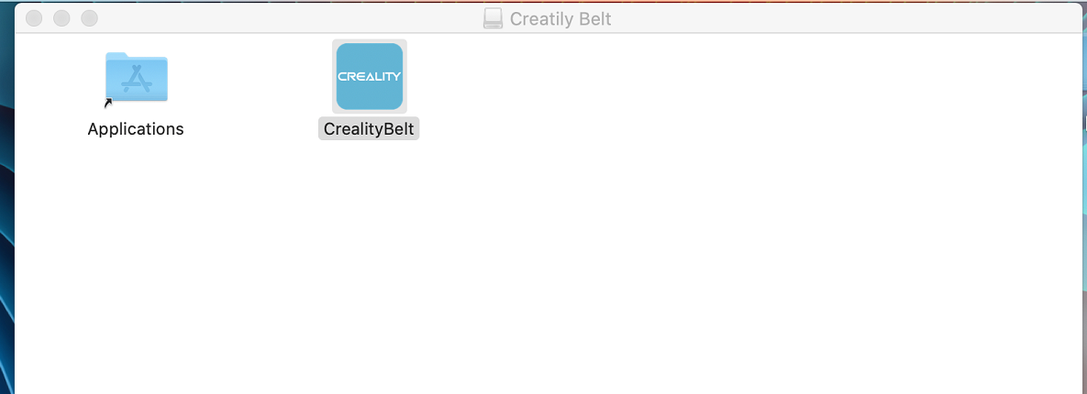

2. If you directly double-click to open the software, it will appear:
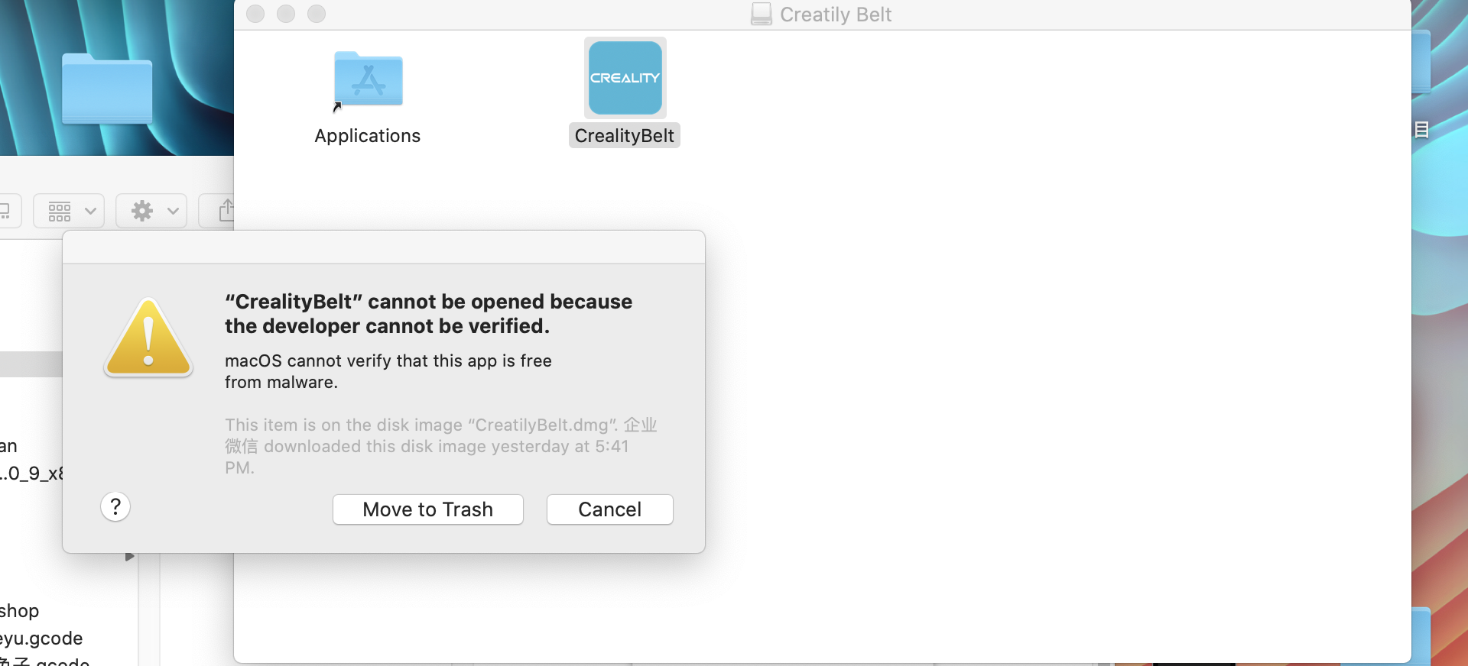

3. So first right click, then select open from the options:
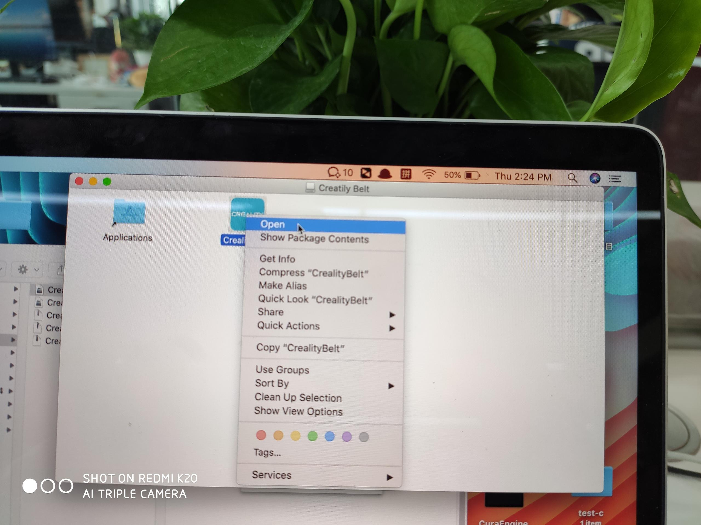
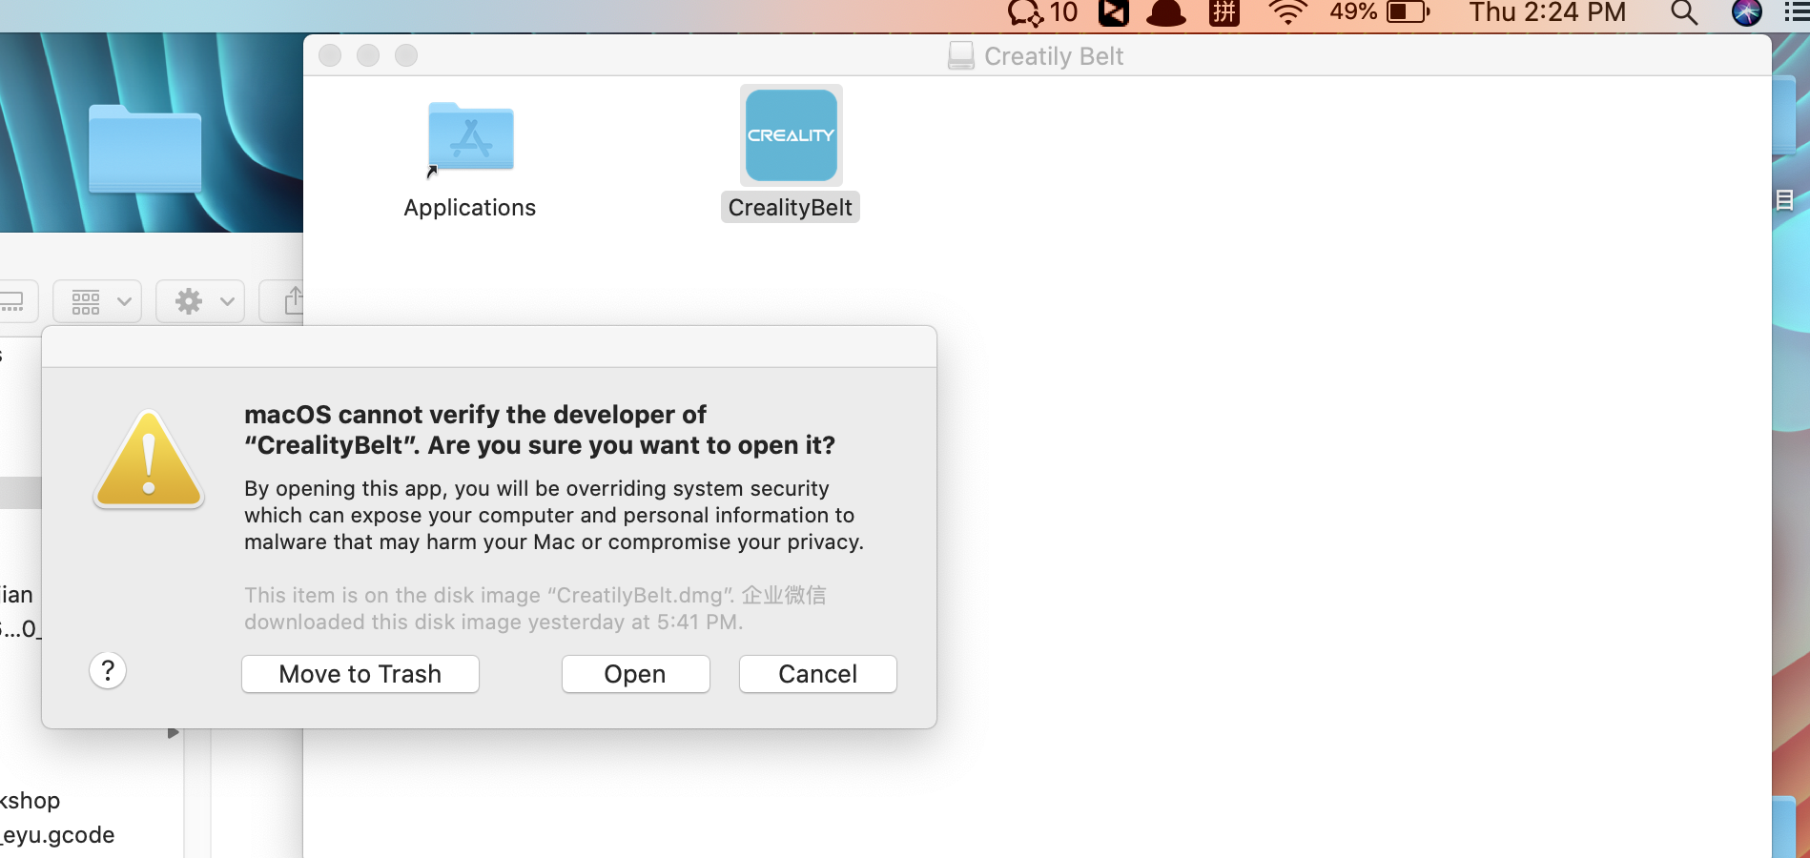

Attentions：This option is OK as long as it is opened for the first time, but it is not necessary after verification. Double-click to open it later
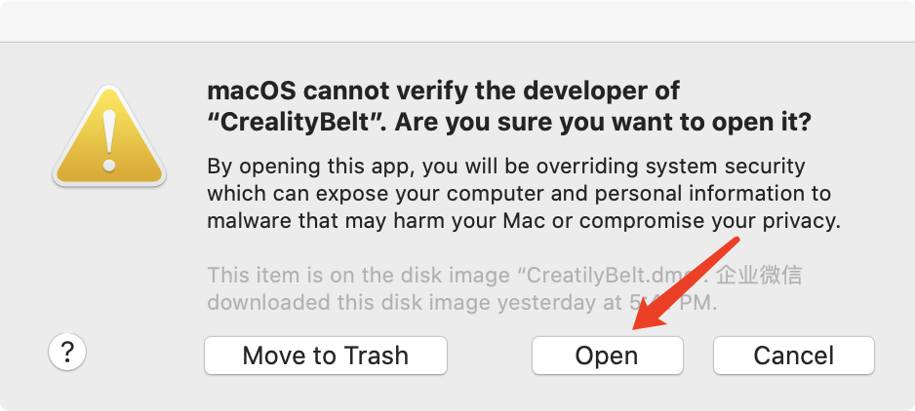

4.Open it normally
