

Health and Safety in the Workplace

Student Resource

Table of Contents

Workplace Health and Safety 3
Industry Regulations and Codes of Practice 3
Model WHS Laws 3
Employer Responsibilities 5
Employee Responsibilities 5
Workplace Hazards 5
Common Hazards in an Office Environment 6
Assessing Risks 8
The Hierarchy of Risk Control 9
Worker’s Rights under WHS Laws 11

Workplace Health and Safety

Industry Regulations and Codes of Practice
All workers in Australia should be aware of their rights and obligations for a safe work environment, as prescribed in the various Workplace Health & Safety (WHS) legislation. State and Territory WHS Acts provide workers and employers with an overview of how to ensure workplaces remain safe and healthy. The Acts also outline the legal responsibilities and duties for employers and business owners.

The WHS Acts are supported by industry regulations and codes of practice. The industry regulations set out standards required for hazards and risks that are specific to various industries. Some examples include; electricity safety, the use of scaffolding, prevention of falls, noise control and the use of protective clothing and equipment. The regulations also specify licences you may require, and the WHS records and reporting requirements.

Codes of practice provide employers and workers with the practical guidance required to achieve the standards specified in the various WHS Acts and Regulations.

Model WHS Laws

Prior to 2011, each of the states and territories in Australian had different Occupational Health and Safety (OHS) laws. In order to achieve greater consistency across the country, the state and territory governments agreed to develop model laws (WHS Act and Regulations), on which each state or territory could base their individual health and safety laws. Safe Work Australia is responsible for the development of these ‘model’ laws, however in order for them to become legally binding, each state or territory is required to implement them as their own laws.
As at January 2020, the model WHS laws have been implemented by the Australian Capital Territory, New South Wales, the Northern Territory, Queensland, South Australia, Tasmania and the Commonwealth. To find out more about the model WHS laws refer to the Safe Work Australia website at http://www.safeworkaustralia.gov.au/

Safe Work Australia provides guidelines, training and advice on workplace health and safety issues but does not get involved in regulation or the enforcement of WHS legislation, this is the responsibility of the Commonwealth, state and territory regulators and based on each state or territory’s Work Health and Safety Act.

The following table summarises the various WHS state and territory legislation in Australia as at January 2021.

 | WHS Act | WHS Regulations | WHS Authority & Website
ACT | Work Health and Safety Act 2011 | Work Health and Safety Regulation 2011 | WorkSafe ACT  www.worksafe.act.gov.au/health_safety
NSW | Work Health and Safety Act 2011 | Work Health and Safety Regulation 2017 | SafeWork NSW  www.safework.nsw.gov.au
NT | Work Health and Safety (National Uniform Legislation) Act 2011 | Work Health and Safety (National Uniform Legislation) Regulations (NT) | NT WorkSafe  www.worksafe.nt.gov.au/
QLD | Work Health and Safety Act 2011 | Work Health and Safety Regulations 2011 | Workplace Health and Safety Queensland  www.worksafe.qld.gov.au/
SA | Work Health and Safety Act 2012 | Work Health and Safety Regulations 2012 | SafeWork SA  www.safework.sa.gov.au/
TAS | Work Health and Safety Act 2012 | Workplace Health and Safety Regulations 2012 | WorkSafe Tasmania  www.worksafe.tas.gov.au/
VIC | Occupational Health and Safety Act 2004 | Occupational Health and Safety Regulations 2017 (Vic) | WorkSafe Victoria  www.worksafe.vic.gov.au/
WA | Work Health and Safety Act 2020 | Work Health and Safety (General) Regulations 2022 | WorkSafe WA  www.commerce.wa.gov.au/WorkSafe/
Common-  wealth | Work Health and Safety Act 2011(Cth) | Work Health and Safety Regulations 2011 (Cth) | Comcare  www.comcare.gov.au

Employer Responsibilities

Employers are required to provide a healthy and safe working environment for themselves, workers, customers and visitors. This includes:

- Eliminating or minimising hazards and risks in the workplace
- Providing WHS information, instructions and training to employees
- Providing employees with protective clothing and safety equipment appropriate for the workplace, and
- Implementing systems, policies and procedures for the reporting of accidents, incidents and hazards

Employee Responsibilities

Employees are required to:

- Take reasonable care for their own safety
- Consider the safety of other people that may be affected by their actions
- Use WHS and maintain equipment appropriately
- Follow reasonable health and safety related instructions given to them by their employer
- Follow WHS policies and procedures for reporting and minimising hazards and risks in the workplace

Workplace Hazards

A workplace hazard is something that has the potential to cause harm or injury to a person in the workplace. The types of hazards will depend on the organisation and the work environment, for example common hazards on a mine site will be different to those in an office environment. Depending on your work environment, hazards may include:

- physical (working at heights, falling objects, electricity, trip hazards)
- chemical (poisons, hazardous materials)
- biological (blood, viruses, bacteria)
- environmental (air pollution, excessive noise, hot/ cold temperatures)
- psychological (stress, bullying)
- ergonomic (chair and desk alignment)

Workplace hazards can be identified by personal observation, inspecting the workplace and talking to other workers, supervisors or health and safety representatives or professionals. It is important to be aware of the common hazards in your workplace and to immediately report any hazards you become of aware of.

Common Hazards in an Office Environment

The most common hazards found in administration or office environments include:

- Poorly designed furniture or equipment (i.e. computer workstations)
- Slips, trips and falls
- Electrical hazards from appliances or faulty sockets
- Manual handling (i.e. moving heavy furniture)
- Poor lighting or ventilation
- Repetitive actions (i.e. typing)
- Bullying and stress
- Contagious illness spread by co-workers (virus including Covid-19).

Your organisation should have forms, documents, policies and procedures readily available to staff, that dictate how and to whom you report any identified hazards. Below is an example of an organisation’s Hazard Report Form.

Assessing Risks

A risk is the possibility that some harm (injury, illness or death) might come to a person as a result of being exposed to a hazard in the workplace. Workplace risks should be assessed to determine what could happen if the person is exposed to the hazard and the likelihood of this outcome occurring. In order to determine this, a risk assessment should be performed.

A risk assessment will help determine:

- how severe the risk is
- what action you should take to eliminate or minimise the risk, and
- how urgently the action needs to be taken

The type of risk assessment undertaken will depend on the hazard. The risk assessment for minor hazards/ risks can be relatively simple, such as a conversation with your co-workers and supervisors. For high risk activities such as live electrical work or entering confined spaces, the risk assessment process will be more complicated and may be specified in relevant industry regulations and codes of practice.

A risk matrix can be used to determine the risk rating, by combining the likelihood of the consequence occurring and the severity of the possible outcomes.

 | LIKELIHOOD
 | Rare | Unlikely | Moderate | Likely | Almost Certain
CONSEQUENCE | Very unlikely to occur | Unlikely to occur | Occurs sometimes | Will probably occur | Almost certain to occur
Insignificant | Low | Low | Low | Low | Moderate
No injuries
Minor | Low | Low | Moderate | Moderate | High
First aid needed
Moderate | Low | Moderate | High | High | Critical
Medical treatment
Major | Low | Moderate | High | Critical | Catastrophic
Disability/ disease
Extreme | Moderate | High | Critical | Catastrophic | Catastrophic
Death

The risk rating will indicate the urgency of the action required as follows:

Low: | No further action required, review periodically
Moderate: | Action required to minimise the risk, review periodically
High: | Action required to minimise the risk, review continuously
Critical: | Immediate action required to minimise the risk
Catastrophic: | Urgent action required to minimise the risk

The Hierarchy of Risk Control

Once the hazards and the associated risks are known, appropriate controls need to be implemented. The hierarchy of risk control can provide you with a system to identify the appropriate control method:

- Elimination: the most effective method of reducing risk involves removing the risk from the workplace. It is not always possible to remove the risk entirely.

- Substitution: the second most effective method of control involves replacing the object or activity with something that does not constitute a risk. An example would be replacing lead paint with a non-lead based paint.

- Isolation: this involves separating the hazard from employees or the public. This can be achieved by erecting barriers or locating hazardous materials away from general work spaces.

- Engineering: involves changing the equipment or activity to reduce the risk, such as adding safeguards to machinery.

- Administrative: includes changing or updating work procedures, installing warning signs or undertaking training.

- Personal Protective Equipment: in situations where the risk cannot be reduced by other means, workers should minimise any potential consequences by utilising protective clothing and equipment, such as safety glasses, harnesses or high-visibility clothing. This is the least effective method of risk control.

Safe Work Australia identifies the following way as the best way of using the hierarchy of control.

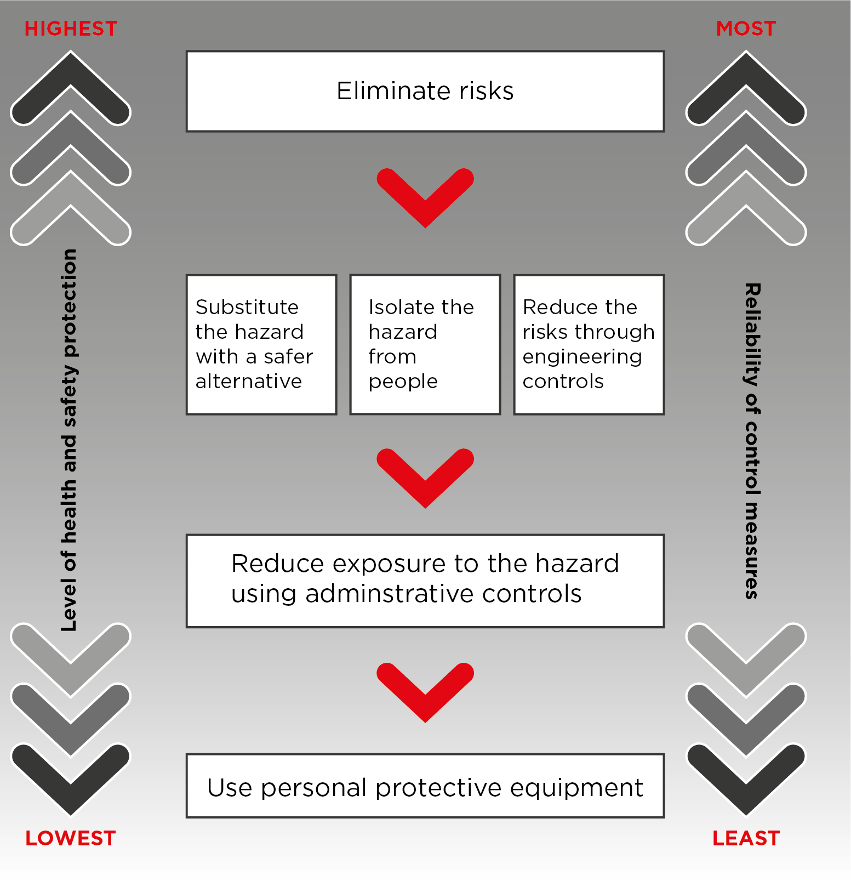

For more information about how to eliminate or minimise workplace risks, refer to the model Code of Practice: How to manage work health and safety risks.

Worker’s Rights under WHS Laws

There are a number of other rights for workers under WHS laws. Workers are entitled to:
- elect a health and safety representative (HSR) if they wish to be represented by one
- request the formation of a health and safety committee
- cease unsafe work in certain circumstances
- have health and safety issues at the workplace resolved in accordance with an agreed issue resolution procedure, and
- not be discriminated against for raising health and safety issues.

Workers have the right under Workplace Health and Safety laws to refuse to carry out or stop unsafe work. They have this right if there is a reasonable concern that the worker will be exposed to a serious risk to their health and safety from an immediate or imminent hazard. This could include exposure to the COVID-19 virus.

Employers must give workers an opportunity to be involved in WHS through:
- Training
- Consultation
- Development of policy and procedures

